**Pseudocode:**

1. Create dictionaries for room numbers, instructors, and meeting times.

2. Prompt user to enter a course number.

3. Use a try-except block to:

a. Display the course details if the course exists.

b. Show an error message if the course does not exist.

4. End program.

**Code:**

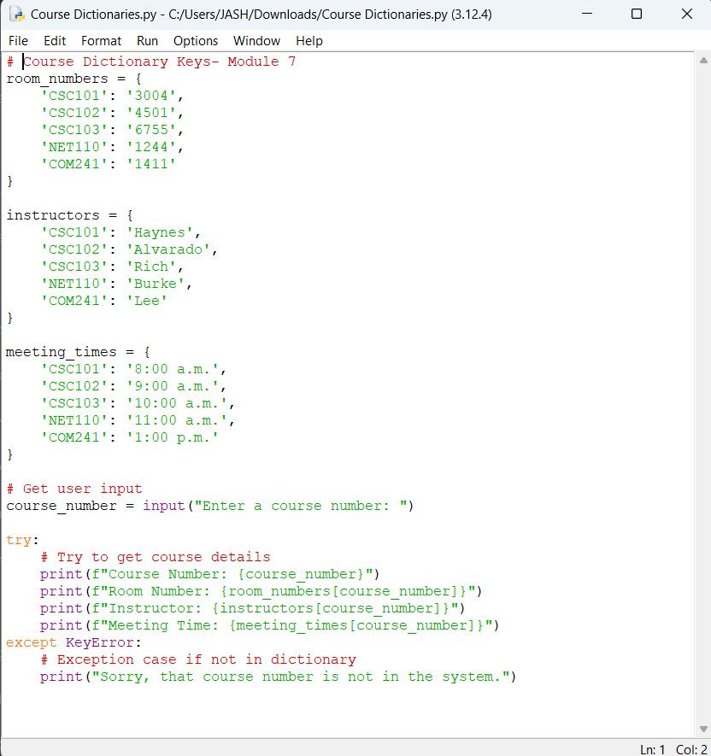

**Executed Code:**

**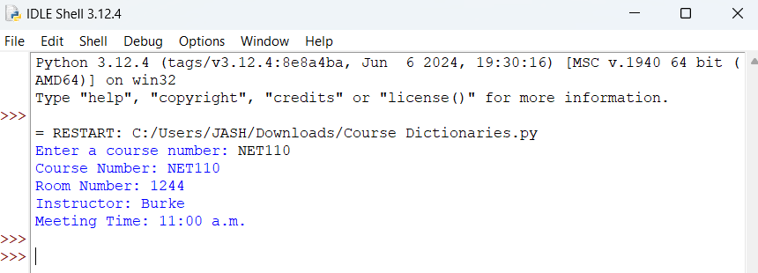  
Also:  
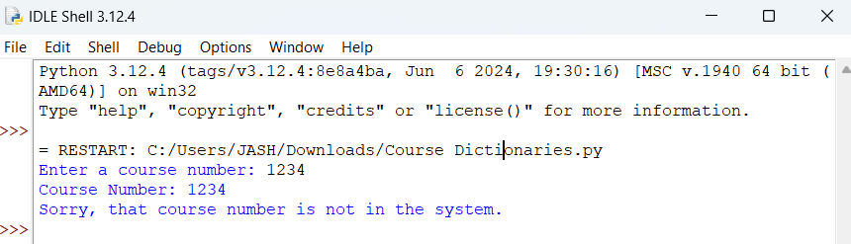  
  
Results:**

| Test Case | Input | Expected Output | Actual Output |
| --- | --- | --- | --- |

| 1 | NET110 | Displays room, instructor, and meeting time for NET110. | Course Number: NET110  Room Number: 1244  Instructor: Burke  Meeting Time: 11:00 a.m. |
| --- | --- | --- | --- |

| 2 | 1234 | Error message: "Sorry, that course number is not in the system." | Error message: "Sorry, that course number is not in the system." |
| --- | --- | --- | --- |